**Predicting the best Location for Indian cuisine in New-York city**

**Chinmay Oak**

**February 19, 2021**

**Index**

**1. Introduction**

1.1 Background

1.2 Problem statement

1.3 Interest

**2.** **Data Sources and Approach**

2.1 Data sources

2.2 Project Approach

3. **Exploratory Data Analysis**

3.1 Extract the names of Borough and Neighborhood from New-york dataset with corresponding Latitudes and longitudes

3.2 Number of Neighborhoods for each borough

3.3 Number of Indian Restaurants for each borough

3.4 Find the number of Indian Restaurants for each neighborhood

3.5 List of likes, Ratings, and Tips for each Indian restaurant using foursquare API

4. **Results**

4.1 Restaurant with Maximum Likes

4.2 Restaurants with Maximum Ratings

4.3 Restaurants with Maximum Tips

4.4 Average rating of Indian Restaurants for each borough

4.5 Location of Restaurant on MAP using Folium

**5.** **Conclusion**

**6. Future Developments**

**1.1 Background**

New York City's demographics show that it is a large and ethnically diverse metropolis. It is the largest city in the United States with a long history of international immigration. New York City was home to nearly 8.5 million people in 2014, accounting for over 40% of the population of New York State and a slightly lower percentage of the New York metropolitan area, home to approximately 23.6 million. Over the last decade the city has been growing faster than the region. The New York region continues to be by far the leading metropolitan gateway for legal immigrants admitted into the United States.

Throughout its history, New York City has been a major point of entry for immigrants; the term "melting pot" was coined to describe densely populated immigrant neighborhoods on the Lower East Side. As many as 800 languages are spoken in New York, making it the most linguistically diverse city in the world. English remains the most widely spoken language, although there are areas in the outer boroughs in which up to 25% of people speak English as an alternate language, and/or have limited or no English language fluency. English is least spoken in neighborhoods such as Flushing, Sunset Park, and Corona. With it's diverse culture , comes diverse food items. There are many resturants in New york City, each beloning to different categories like Chinese , Indian , French etc

**1.2 Problem statement**

## In USA there are many people who like Indian Food but it is hard to find a Good restaurant with High rating and Recommendation. So as part of this project, we will list and visualize all major parts of New York City that has great Indian restaurants.

**1.3 Interest**

* The main object of this project is to find the What is best location in New York City for Indian Cuisine ?
* Which areas have potential Indian Restaurant Market ?
* Which all areas lack Indian Restaurants ?
* Which is the best place to stay if I prefer Indian Cuisine ?

**2.** **Data Sources and Approach**

**2.1 Data sources**

The data sources used are

* Data source : <https://cocl.us/new_york_dataset>

Description - his data set contains the required information. And we will use this data set to explore various neighborhoods of new york city. Indian restaurants in each neighborhood of New York city.

* Data source : Foursquare API

Description : By using this API we will get all the venues in each neighborhood. We can filter these venues to get only Indian Restaurants.

* Data source : <https://data.cityofnewyork.us/City-Government/Borough-Boundaries/tqmj-j8zm>

Description : By using this geo space data we will get the New York Borough boundaries that will help us to visualize choropleth map

**2.2 Project Approach**

* Collect the New York city data from https://cocl.us/new_york_dataset
* Using Foursquare API we will find all venues for each neighborhood.
* Filter out all venues that are Indian Restaurants.
* Find rating, tips and like count for each Indian Restaurants using Foursquare API.
* Using rating for each restaurant, we will sort that data.

3. **Exploratory Data Analysis**

**3.1 Extract the names of Borough and Neighborhood from New-york dataset with corresponding Latitudes and longitudes**

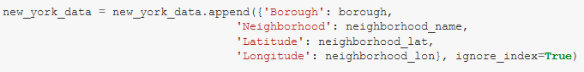

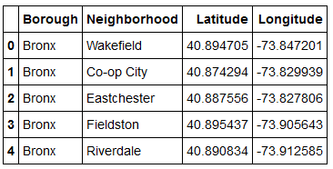

**3.2 Number of Neighborhoods for each borough**

Next step was to find the distribution of Number of boroughs in New York city using a bar plot in the matplotlib library.

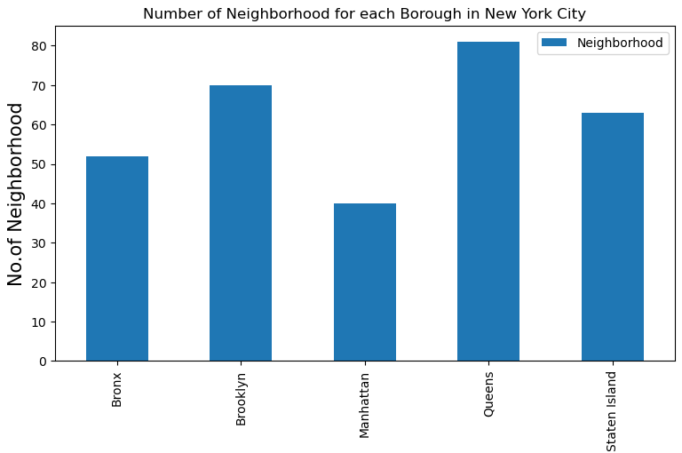

**3.3 Number of Indian Restaurants for each borough**

Next step was to prepare a list of boroughs that contain Indian Restaurants

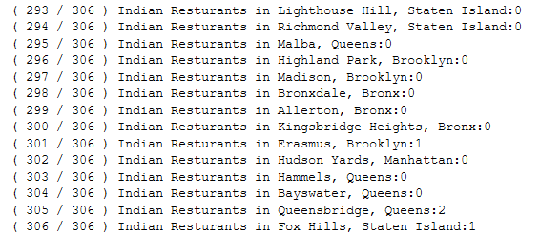

Plot the number of Indian restaurants for each borough

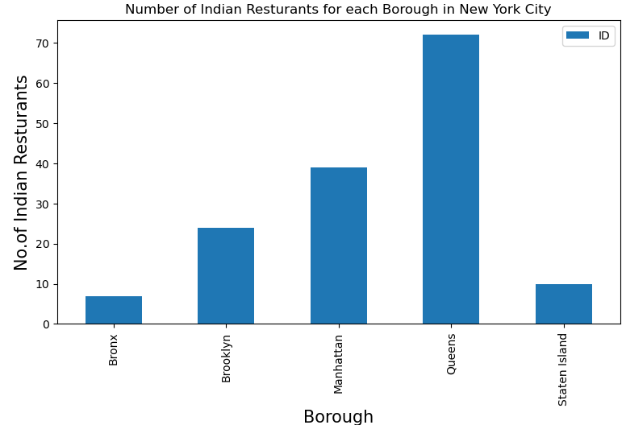

**3.4 Find the number of Indian Restaurants for each neighborhood**

Next step was to prepare a list of neighborhoods that contain Indian Restaurants. Bar plot

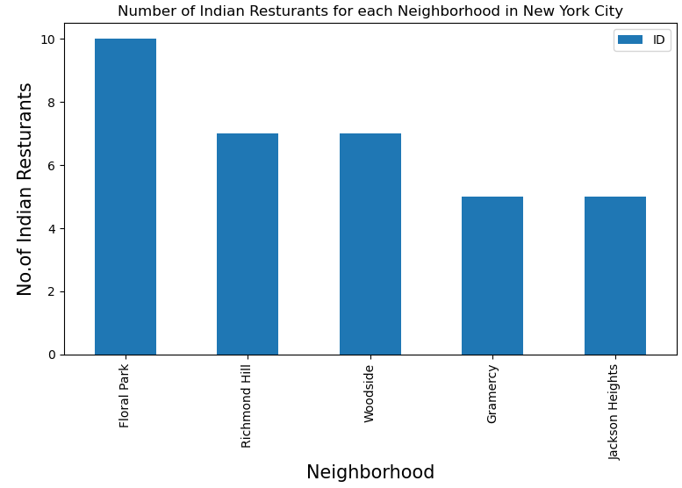

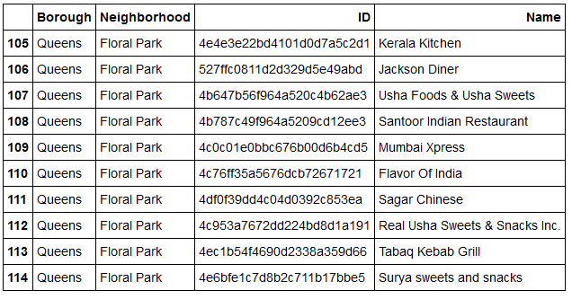

Tabular form

**3.5 List of likes, Ratings, and Tips for each Indian restaurant using foursquare API :**Next step is to extract a table with list of restaurants with likes, Ratings and tips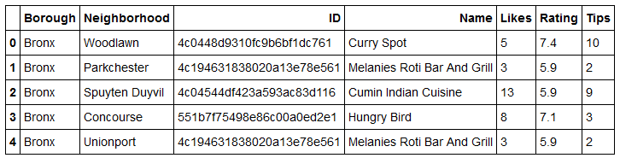

4. **Results**

4.1 Restaurant with Maximum Likes

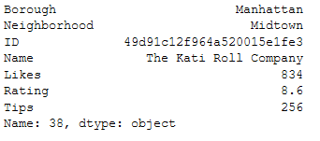

4.2Restaurants with Maximum Ratings

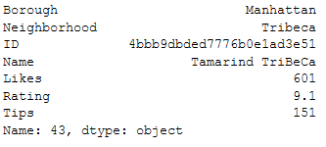

4.3 Restaurants with Maximum Tips

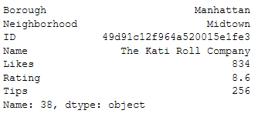

4.4 Average rating of Indian Restaurants for each borough

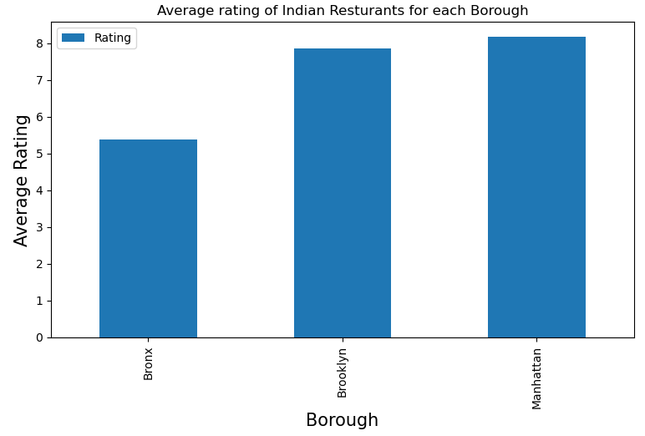

4.5 Location of Restaurant on MAP using Folium

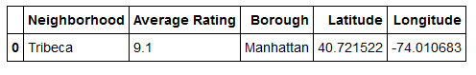

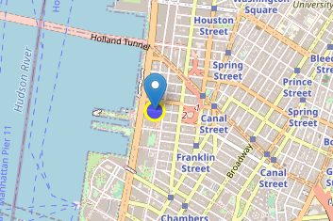

5. **Conclusion:**

In conclusion we were able to derive the following points:

* Astoria(Queens), Blissville (Queens), Civic Center(Manhattan) are some of the best neighborhoods for Indian cuisine
* Manhattan have potential Indian Restaurant Market
* Staten Island ranks last in average rating of Indian Restaurants.
* Manhattan is the best place to stay if you prefer Indian Cuisine.

**6. Future Developments**

As seen from the results we could predict the preferable places to stay according to Indian cuisine in New York. In similar way using the same data analysis approach we can predict the best place to stay according to Indian supermarkets, Indian localities for other parts of country.